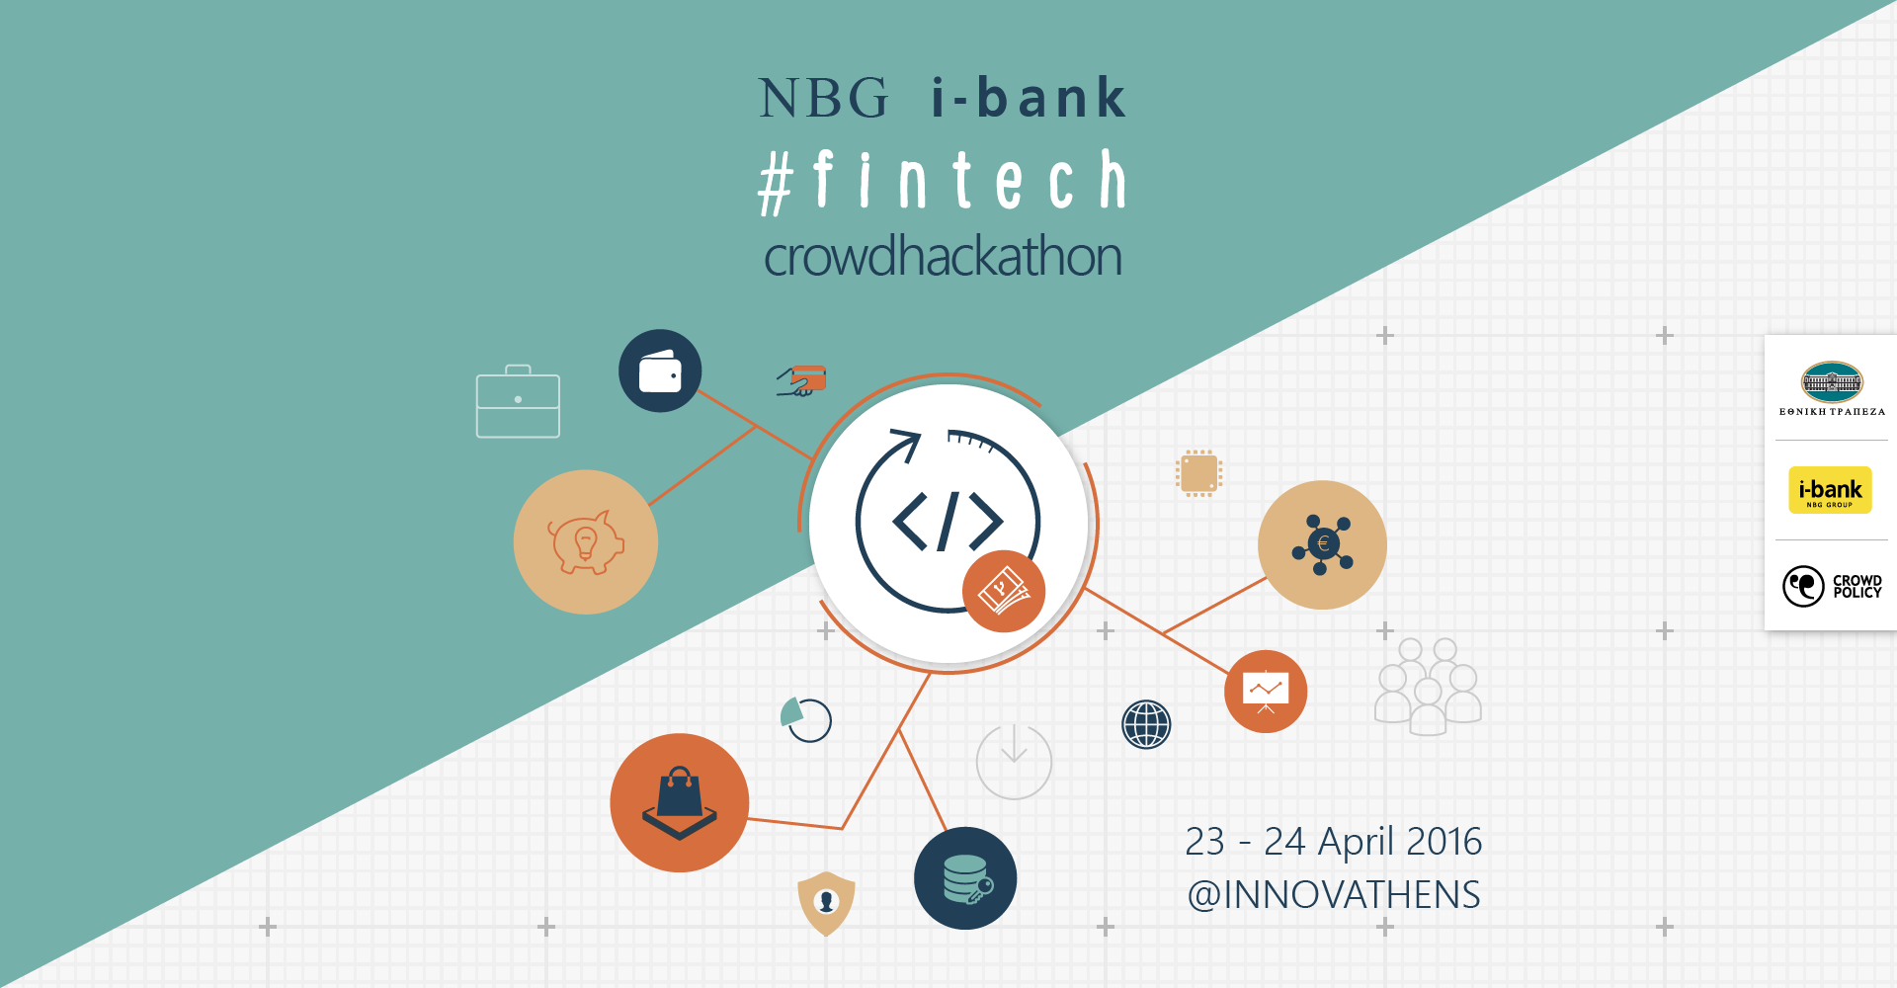

NBG i-bank #fintech crowdhackathon 23 - 24 April 2016 @ Innovathens

Press Release 26.04.2016

The NBG i-bank #fintech crowdhackathon was successfully held on 23-24 April 2016. It is the first hackathon on financial transactions #fintech, a field that becomes increasingly interesting at global level, that has taken place in Greece. It was organized by Crowdpolicy (www.crowdpolicy.com) and it was supported by the National Bank of Greece (www.nbg.gr), as well as other sponsors and supporters.

16 groups in total participated in the NBG i-bank #fintech crowdhackathon on topics in the broader field of financial transactions, such as chatbots, e-wallets, detection of malicious transactions, contracts based on blockchain, crowdfunding functions, mobile transactions through QR codes, social banking, supporting communities with special needs etc.

In addition to the NBG i-bank #fintech crowdhackathon, the Be Finnovative ! workshop was held, during which presentations regarding financial transactions on the fields of donation and investment crowdfunding, mobile banking, chatbots, bitcoin και blockchains etc. took place.

The winners of the competition are the following:
BankBot won the first (1st) place. It is a smart application of automated customer service through Facebook Messenger made by the group Bankship. It wins 1,500 euros in cash from the National Bank of Greece, a contract for provision of services to the National Bank of Greece worth 10,000 euros, consultancy services from Planet worth 2,500 euros and a scholarship from IST Studies.

RSK-Mind of the group RSK Project won the second (2nd) place. It is an application for the detection of malicious transactions which uses smart management of big data and computing learning. It wins 1,000 euros in cash from the National Bank of Greece, a contract for provision of services to the National Bank of Greece worth 5,000 euros and consultancy services from Planet worth 2,500 euros.

The group Elorus with the application SynenosiS and the group Code Burrows with the application Smart Pay shared the third (3d) place. They win 500 euros each from the National Bank of Greece.

Smart Pay allows one to transfer money and make purchases by scanning a QR code through a mobile phone, and the entire process of transferring money from one account to another takes place in the background in an automated way. The group wins a contract with the National Bank of Greece worth 5,000 euros and consultancy services from Planet worth 2,500 euros.

The following five groups share the fourth (4th) place: Big DataNauts with the application saferandom, 3+1 with the application Referral, Community, Crowd contract and Antigravity. They win a virtual prepaid Mastercard with a balance of 200 euros per group. Moreover, the group Community wins the Bluegrowth prize which consists of consultancy services worth up to 5,000 euros.

Watch the awarding video https://goo.gl/M9jpX6

Mrs. Nelly Tzakou-Lambropoulou, General Manager of Retail Banking of the National Bank of Greece stated: “Since the last year's competition of innovation and technology of the National Bank of Greece we announced that we would create the i-bank app store to strengthen the ecosystem of mobile applications' development and the dynamics of youth entrepreneurship around it. Engaged in our commitment, we held the first fintech hackathon based on openbank API in collaboration with Crowdpolicy. The participation of young people with high-level expertise and skills proved our ground-breaking action right and proved that the human resources of our country constitute one of the key pillars in achieving sustainable development. The solutions presented and implemented on a satisfactory level by the contestants impressed us and proved that there are great opportunities for cooperation between the banking sector and fintechs. We would like to thank them for the trust they showed us and we assure them that we will continue supporting the ecosystem with similar initiatives and actions.”

Mr. Nikos Christodoulou, General Manager, Group Chief Information Officer at National Bank of Greece stated: “ When, as the National Bank of Greece, we undertook the initiative to be the first Bank in Greece and one of the few in Europe to “open” our applications publicly through API, that is to give companies and groups of developers the opportunity to use them, we did not expect such an immediate response. The groups that competed showed great familiarity with them under a strict time frame and were able to utilize them by proposing smart ideas that complement and give additional value to our services.”

What is especially important is the Open Bank API that was announced by the National Bank of Greece in the framework of the NBG i-bank #fintech crowdhackathon. The API of the National Bank of Greece gives any developer or company the opportunity to safely connect to the systems of the bank, in accordance with the conditions set, and make transactions in real time. It is the first time in Greece that an API is provided by a bank and among the few at European level, and it will pave the way to the development of fintech applications. In particular, adopting an open model is of added significance, as it contributes even more to the local economy and development. https://goo.gl/jjVXbC

We would like to thank the contestants, the mentors, the judges, the volunteers as well as the sponsors, and especially the National Bank of Greece as well as Mastercard, IST Studies, Microsoft, Amazon, Bluegrowth, Scooterize, e-food.gr, the Athenian Brewery, Sourcelair, Red Bull and UBER. We would also like to thank the communication sponsors TO VIMA, GTP Headlines, insider.gr, XRIMA, startupper.gr and the supporters for their precious help. Finally, we would like to thank the speakers and participants at the Be Finnovative ! Workshop.

The presentations of all the groups, the code, the documentation, as well as photographs and videos will be soon available online at the address http://goo.gl/5oTK0Z. You can find more information at http://crowdhackathon.com/fintech/ and www.crowdhackathon.com.

Information:

Crowdpolicy Digital Participatory Services
5 Protogenous Str. - Athens
Tel: +30 2122134475
www.crowdpolicy.com
hello@crowdpolicy.com

